PRIF SIOE LAETH CYMRU / WELSH DAIRY SHOW
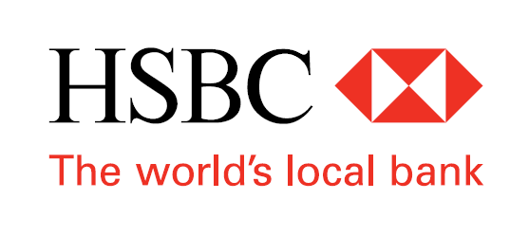
THE CALF AND HANDLER SHOW ENTRY FORM
TUESDAY 23RD OCTOBER 2017 @ 6.00pm

EXHIBITOR’S NAME

ADDRESS

POST CODE |  | 

Hauliers Registration Number ....................................................................................

CLASS NO. | NAME OF ANIMAL &  HERD BOOK NO | D.O.B | HANDLER’S NAME | HANDLER D.O.B

PLEASE RETURN TO THE SHOW OFFICE BY 12 NOON, WEDNESDAY 11th OCTOBER 2017- No late entries will be accepted.
THE WELSH DAIRY SHOW, The Showground, Nantyci, Carmarthen, Carmarthenshire SA33 5DR.
 01267 232141  01267 221884
CLASS NO. | NAME OF ANIMAL &  HERD BOOK NO | D.O.B | HANDLER’S NAME | HANDLER D.O.B

